- SOLKAR PANELS
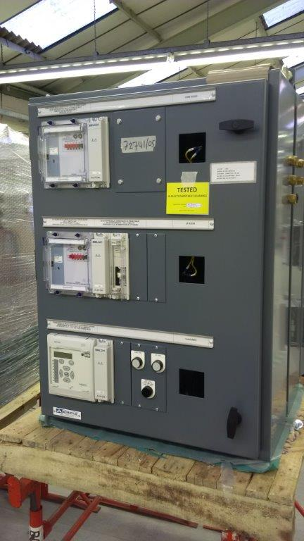
Panel Type: Solkar Relay Panel
Destination: United Kingdom
Project: Scottish Power Networks, UK.
Application: Solkar Relay Protection Panel
Highlights: Pilot Wire Protection for Cable Feeders
- Toshiba – 220kV/33kV CRP+SAS
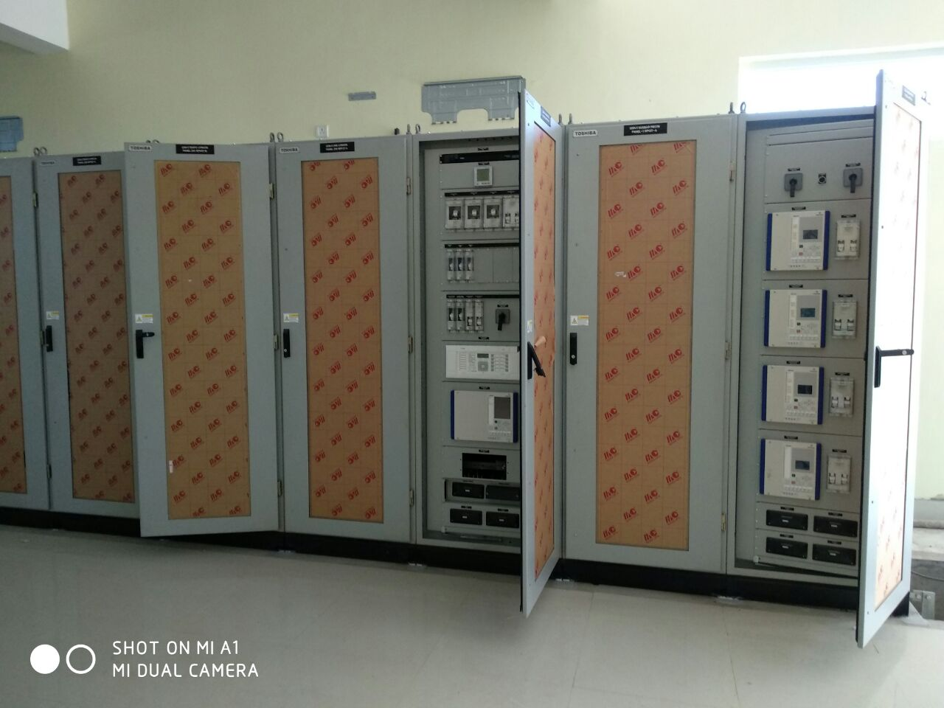
Panel Type: 220kV & 33kV Control & Relay Panels
Destination: Odisha, India.
Project: Odisha Power Transmission Corporation Ltd (A Govt enterprise).
Application: Line / Transformer Differential /Bus Bar Differential / Bus Coupler / Substation Automation System
Highlights: Substation Automation System (Toshiba Make)

- Toshiba 245kV GIS Local Control Panel
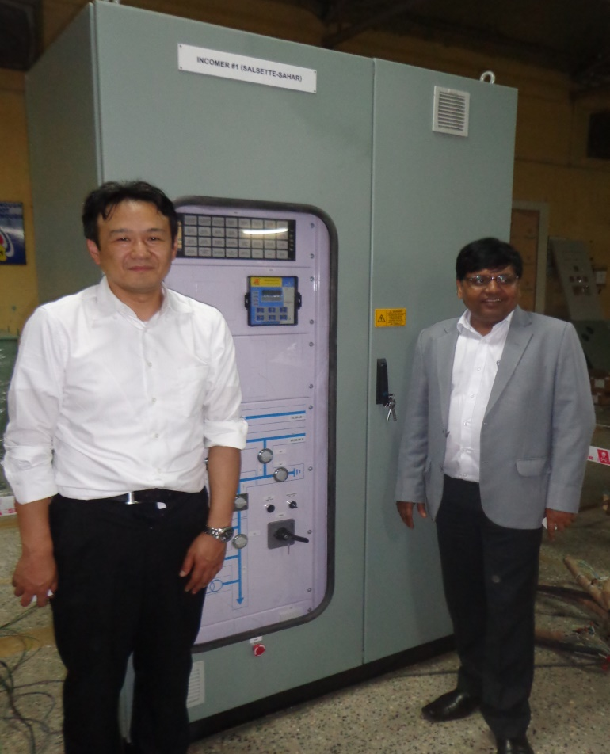
Panel Type: 245kV GIS Local Control Panel
Destination: Tata Power, Mumbai.
Project: Tata Power Project
Application: Local Control Panel for 245kV Gas Insulated Switchgear system
Highlights: 245kV Gas Insulated Switchgear System

- ORIANO SOLAR PROJECT
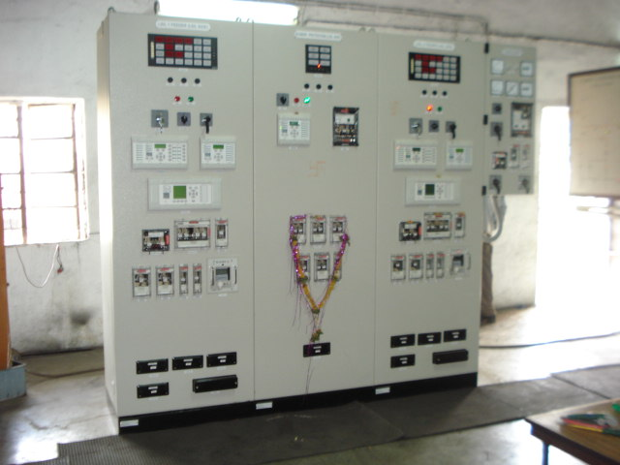
Panel Type: Simplex Type Line & Transformer Control & Relay Panel
Destination: Oriano Solar Project in Karnataka, India.
Project: Solar Project
Application: Control & Relay Panels in 66kV Substation.

- ABB – Shree Cements Ltd, Chhattisgarh, India
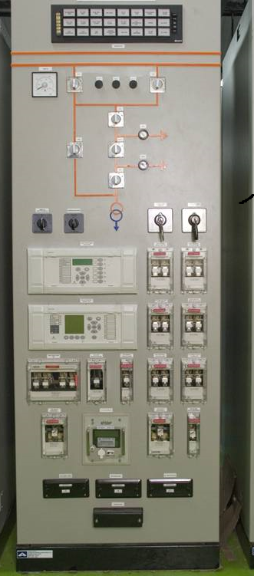

Panel Type: Simplex Type Line cum Transformer Control & Relay Panel
Destination: Shree Cements, Chhattisgarh.
Project: Cement Plant (Shree Cements Ltd)
Application: 132kV Control & Relay Protection Panel

- Sumangla Steels, Pondicherry
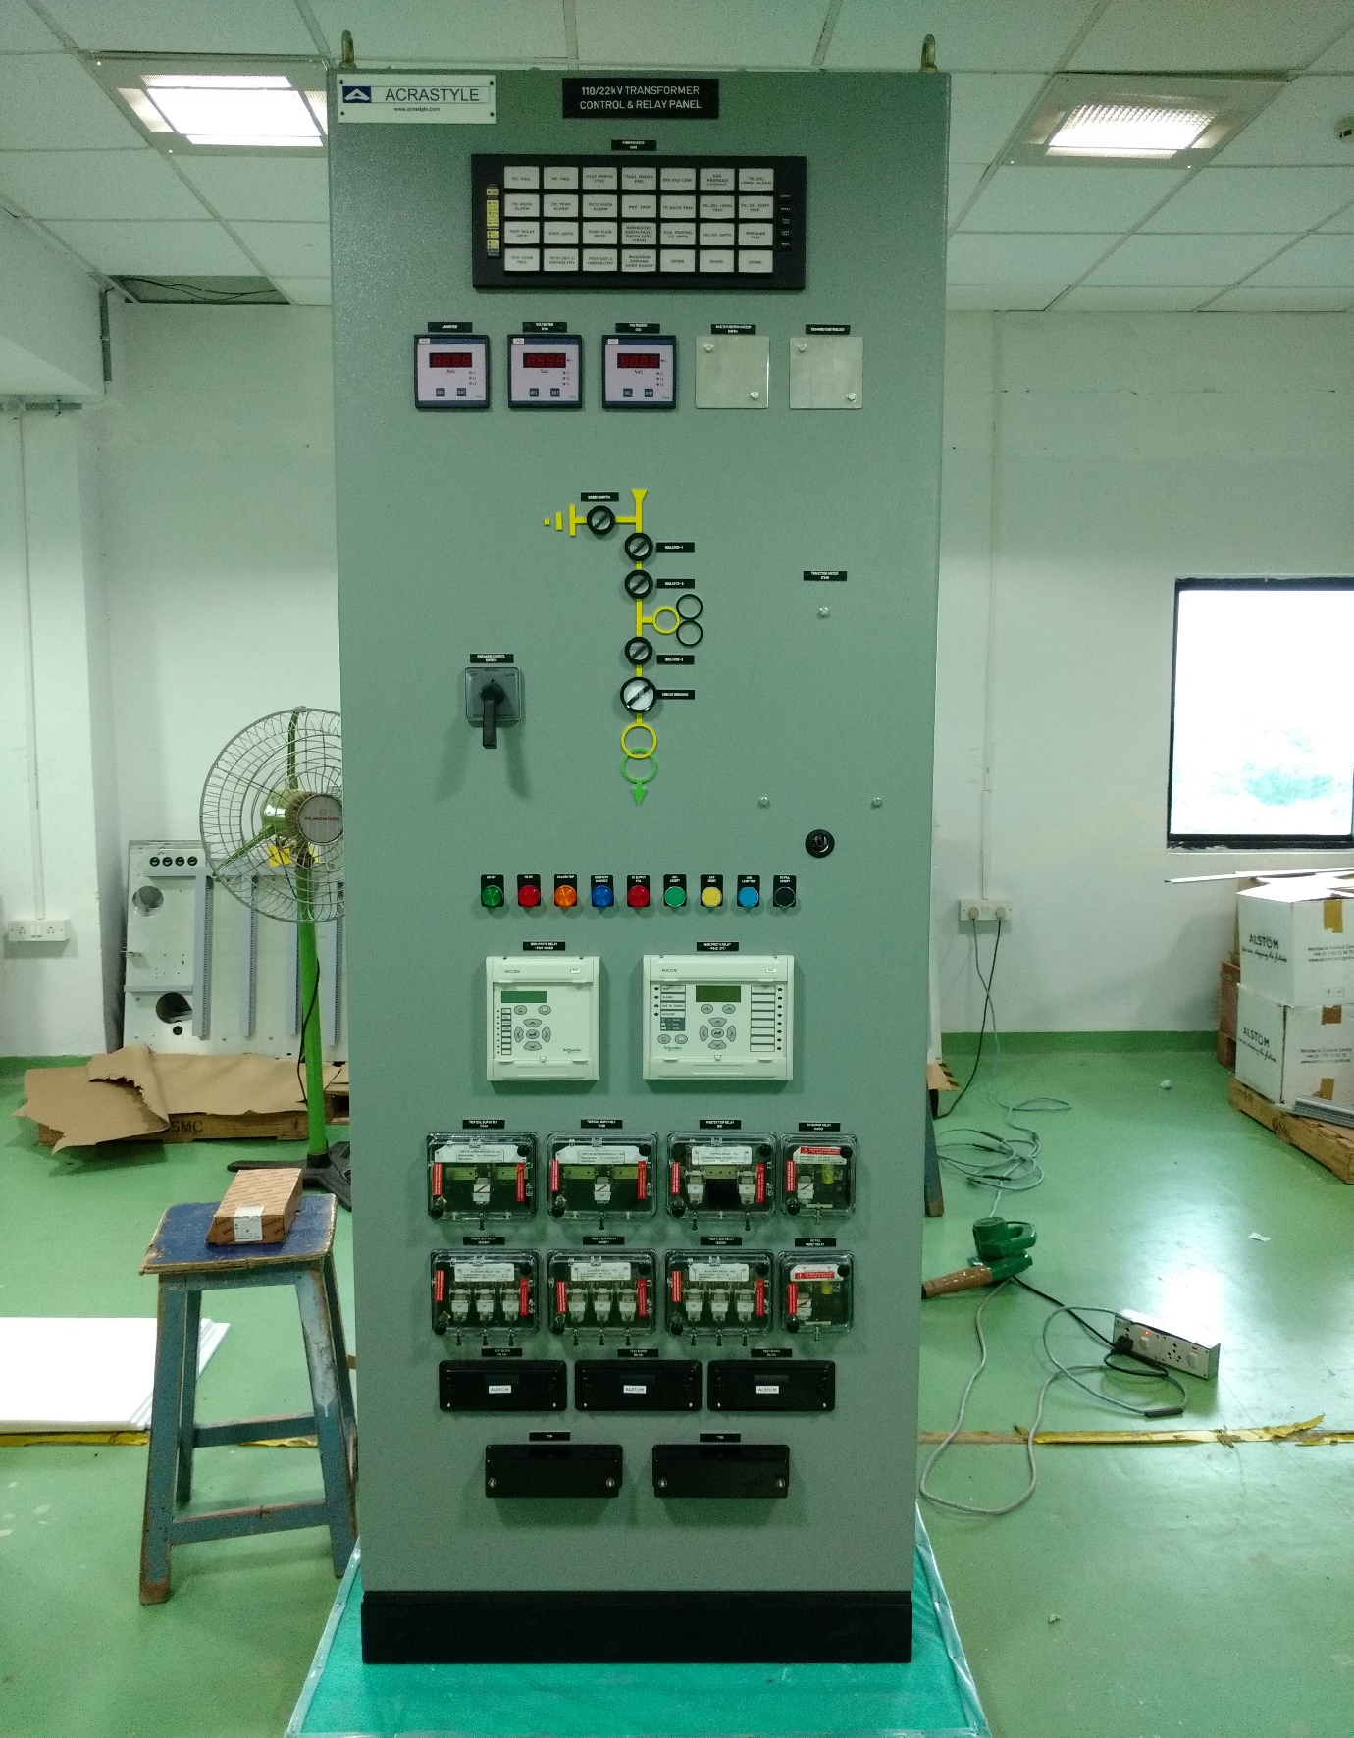
Panel Type: Simplex Type 110kV Transformer Control & Relay Panel
Destination: Sumangla Steels, Pondicherry.
Project: Steel Plant (Sumangla Steels, Pondicherry)
Application: 110kV Transformer Control & Relay Protection Panel
- FLSmidth
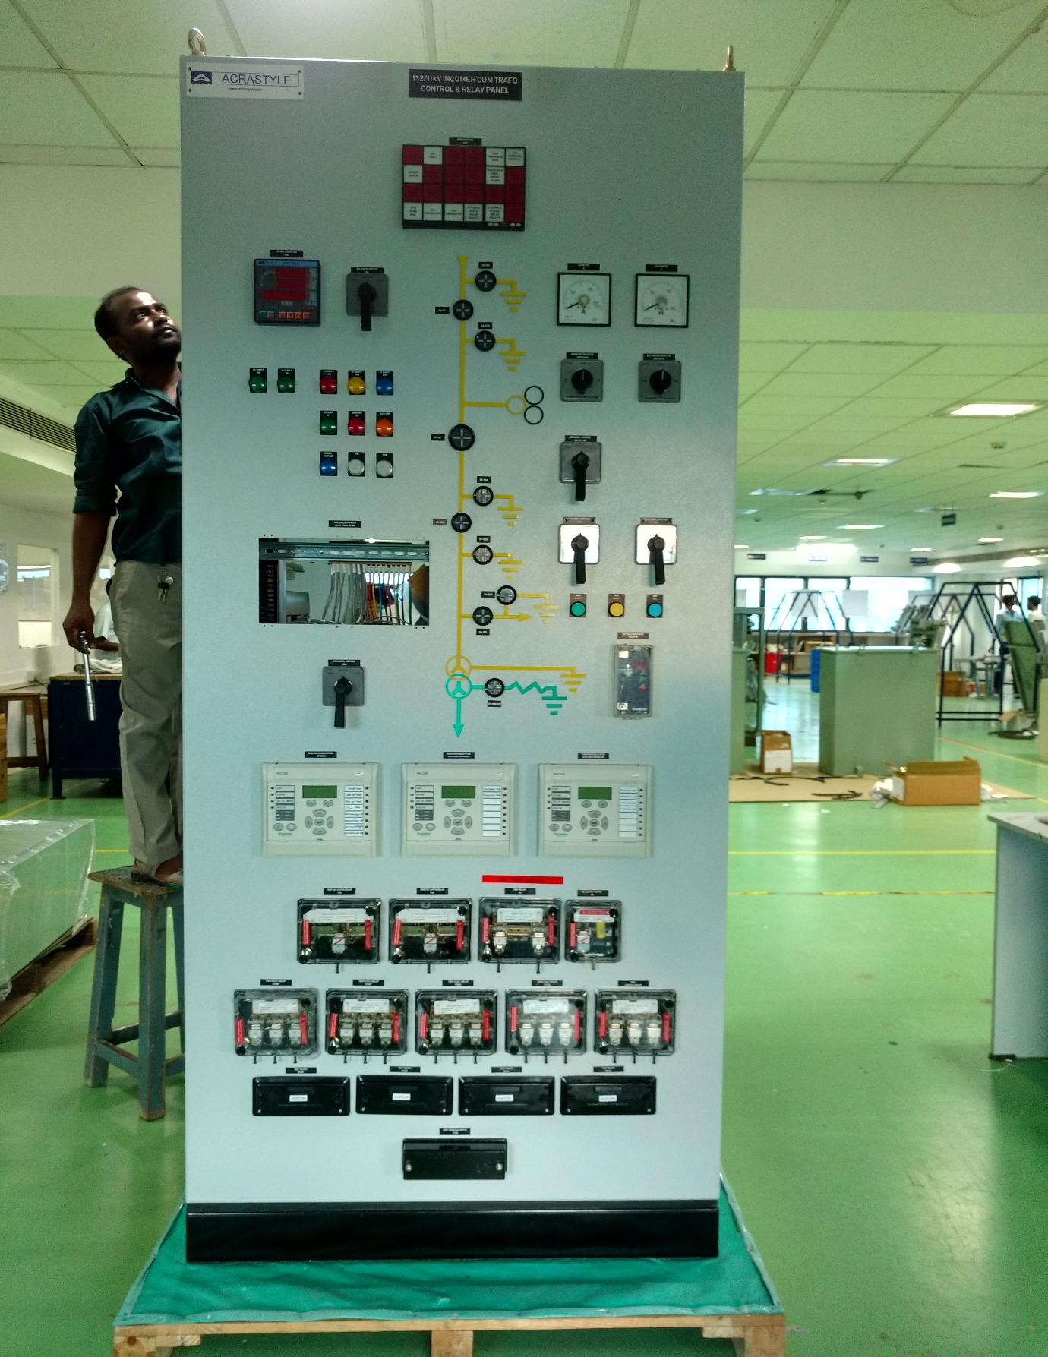
Panel Type: Simplex Type 132kV Line cum Transformer Control & Relay Panel
Destination: Emami Cement Plant, Chhattisgarh.
Project: Cement Plant, (Emami Cement Plant)
Application: 132kV Line cum Transformer Control & Relay Protection Panel
- Regen Power Tech
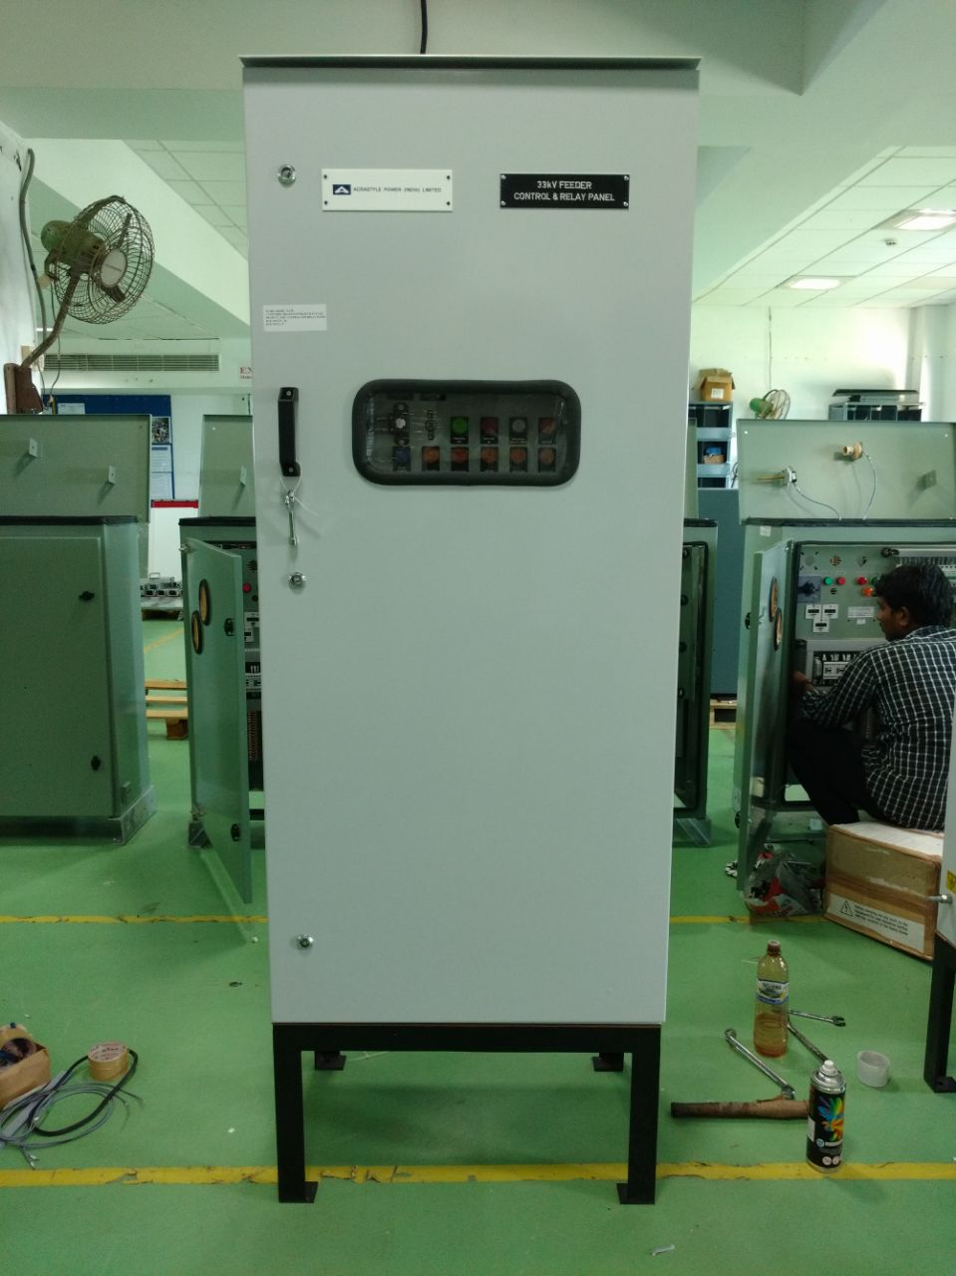
Panel Type: 33kV Control & Relay Panel
Destination: Kamatchipuram, Tamil Nadu.
Project: Wind mills.
Application: 33kV Control & Relay Panel for ABB Make Breaker
- GL318 – GE
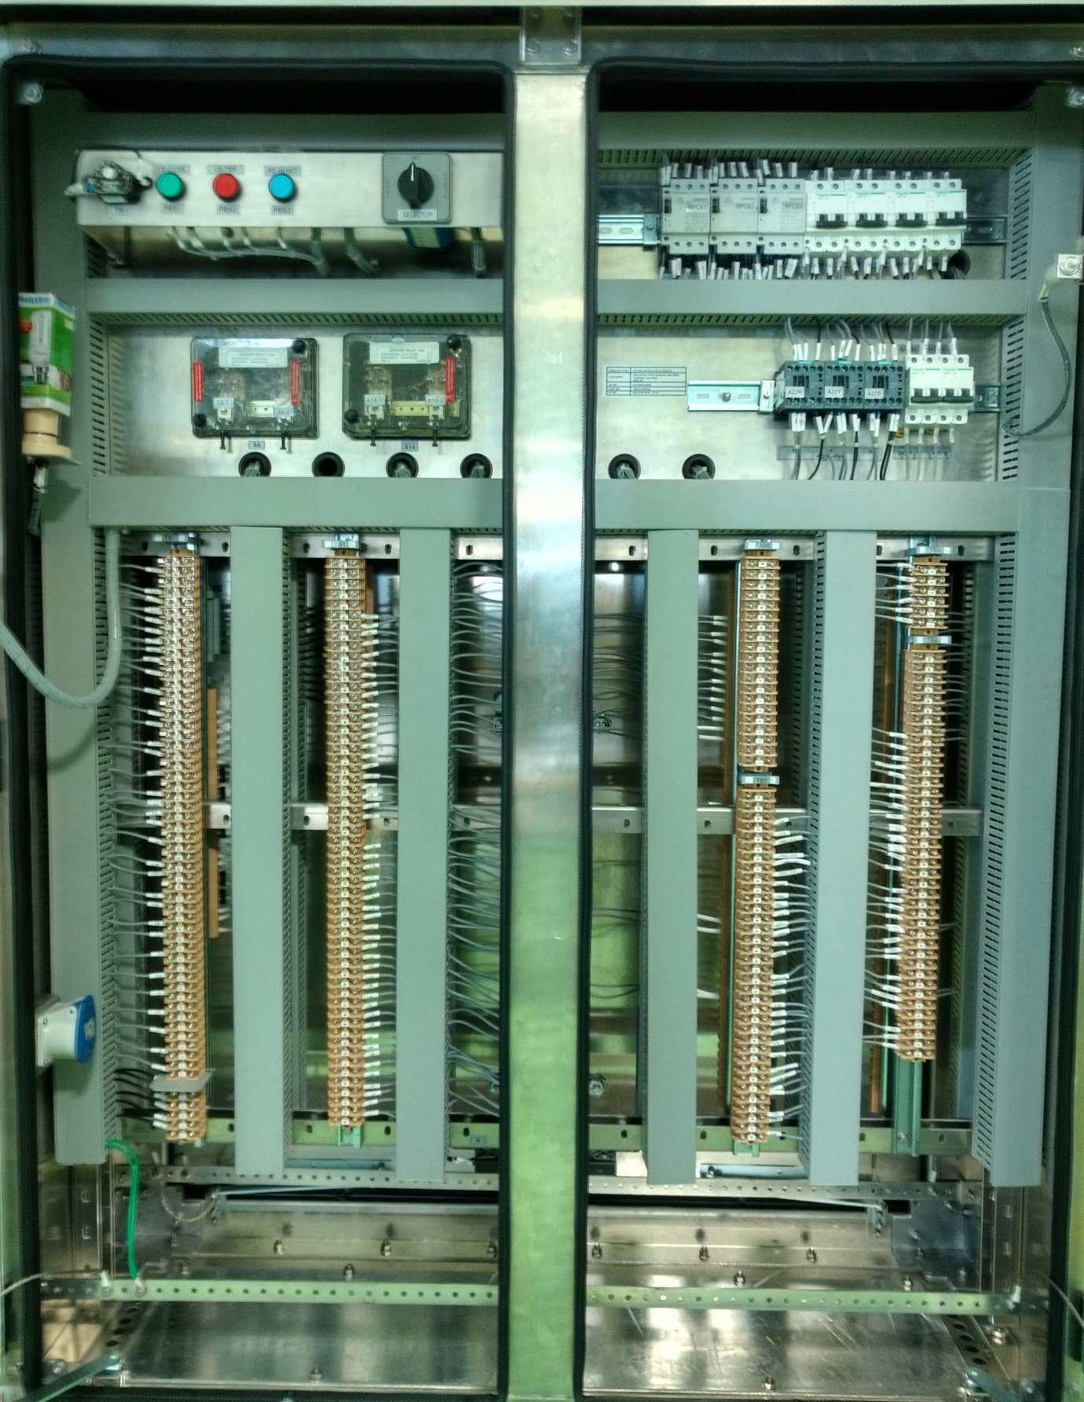
Panel Type: GL 318 – 765 kV LVCC Panel
Destination: GE Padappai
Project: GE Padappai
Application: 765 kV SF6 Breaker Panel
- Dhandapani Cements
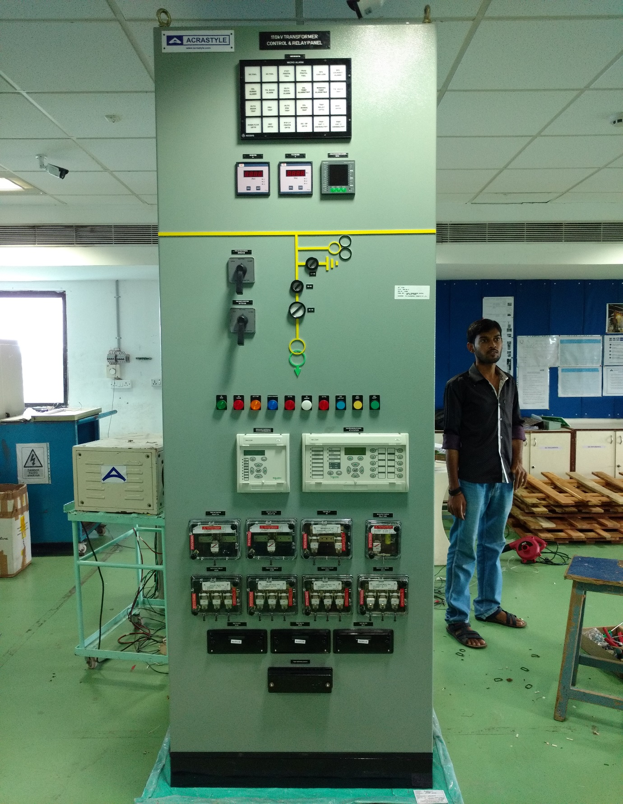
Panel Type: 110 kV Transformer Control & Relay Panel
Destination: Dhandapani Cements, Trichy, Tamil Nadu
Project: Dhandapani Cements
Application: 110 kV Transformer Control & Relay Protection Panel

